Date | Version | Description | Name
12/11/2025 | 1.0 | Created the UML diagram | Brayan
12/11/2025 | 1.0 | Add discriptions | Shar Min

UML Diagram
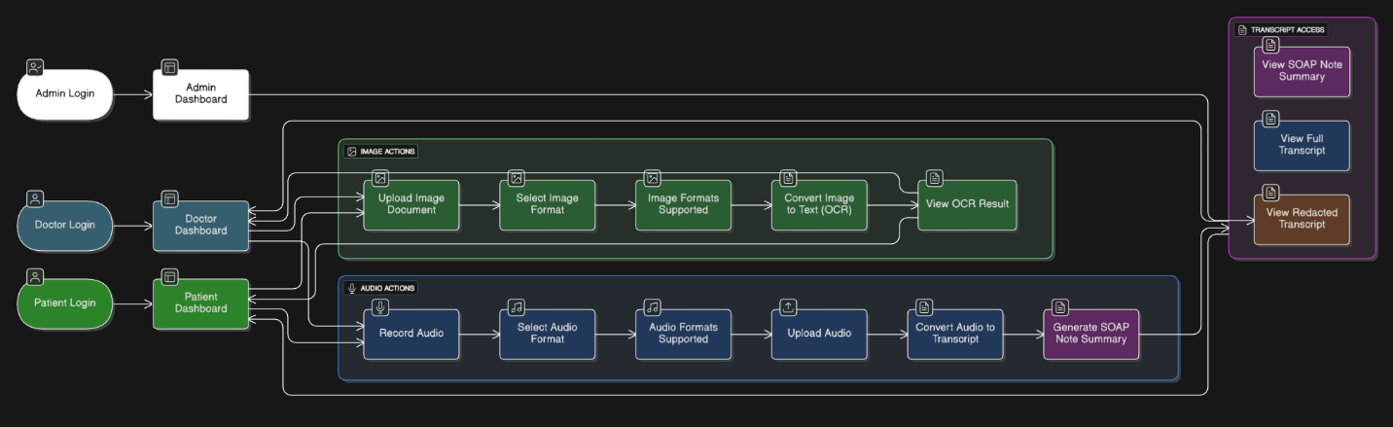

1. User Roles & Entry Points
The system supports three main user types, each beginning at their own login screen:
- Admin Login/Admin Dashboard
Admins oversee system activity, manage users, and access global features.
- Doctor Login/Doctor Dashboard
Doctors perform clinical actions such as recording audio, uploading documents, and reviewing transcripts.
- Patient Login/Patient Dashboard
Patients can view their own transcripts, summaries, and related information shared by their provider.
Each dashboard gives access to the same processing pipeline but with different permissions.

2. Image Actions (OCR Processing Pipeline)
This workflow handles converting medical documents into digital text:
- Upload Image Document
User uploads medical forms, lab results, or images.
- Select Image Format
The system confirms the file type (PNG, JPG, PDF, etc.).
- Image Formats Supported
Validation ensures that the file type is allowed.
- Convert Image to Text (OCR)
The server extracts text using optical character recognition.
- View OCR Result
Users review accurate text extracted from the uploaded document.
Admin, Doctor, and Patient dashboards may initiate this process depending on permissions.

3. Audio Actions (Speech-to-Text & Diarization Pipeline)
This section represents the core audio-processing features built using Whisper and Pyannote.audio:
- Record Audio
Users capture a doctor & patient conversation in real-time.
- Select Audio Format
The system verifies the audio format (WebM, WAV, MP3, etc.).
- Audio Formats Supported
Ensures compatible input formats.
- Upload Audio
The recorded or imported audio file is sent to the backend.
- Convert Audio to Transcript
Whisper transcribes spoken words into text.
- Generate SOAP Note Summary
A clinical summary (Subjective, Objective, Assessment, Plan) is produced using the transcript.
Both Doctors and Patients can trigger the audio processing pipelines through their dashboards.

4. Transcript Access Features
After audio or document processing, the system provides three major components:
- View SOAP Note Summary
The LLM generated clinical summary.
- View Full Transcript
The unedited transcription of the entire conversation.
- View Redacted Transcript
A protected version with all PII removed.
These features are reachable from any dashboard that initiated audio or OCR processing.

5. System Flow Summary
Overall, the diagram shows how:
- Users authenticate then land on their dashboards
- Dashboards provide access to Image Actions, Audio Actions, and Transcript Viewing
- Processing pipelines run on the backend
- Results (OCR, transcript, SOAP note, redacted transcript) return to users through unified access points
This UML demonstrates a modular architecture, where each processing pipeline is separated but all flow into the central transcript-review interface.

